
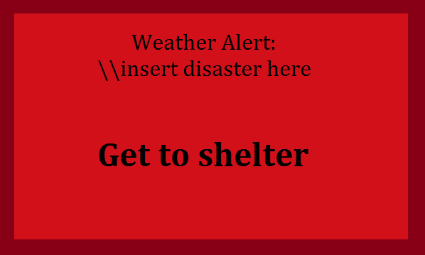
Dear Developer(s),
Our robotics team, Iron Reign, would like to know if you would be interested in developing a multiplatform program that alerts the user to weather emergencies in the user’s zip code. It would get this information by pulling data from a central server which is connected to IPAWS-OPEN, which uses SOAP over HTTPS. This server would have a listing of live weather events from IPAWS-OPEN. This project would be open-source, on Github. This project would be licensed under the GNU GPL Version 3, a copyleft license, or Apache 2.0, an open source license that allows for resell. If you agree, we would like it to fit these specifications:
- Provided with a zip code, it should detect weather emergencies by connecting to a server
- Clients – Tomato router, Windows, Linux, Mac OSX
- A webservice that processes alerts from IPAWS-OPEN & forwards to client’s programs.
We need you to use Tomato, a router firmware. We would like to develop a plugin that connects to our webservice and, upon receiving an emergency alert, it would inject script into the webpages that would display an alert that covers the screen, the (bad) mockup below. For Windows, Mac OSX, and Linux, we would like to develop a program that would pop up on the screen when a weather alert happens. We would also present this project to game developers, asking them if they would like to include the program into their games. We would like a beta by January 30th, or at least a mockup of such
If you agree to accept this project, we will be very grateful to you. This project will hopefully save lives from multiple types of disasters like tornadoes or hurricanes.

Many thanks,
Iron Reign Robotics Team

